**Phase 8: Data Management & Deployment**

Performing Data import wizard

1. Making a .csv file for the charging station records

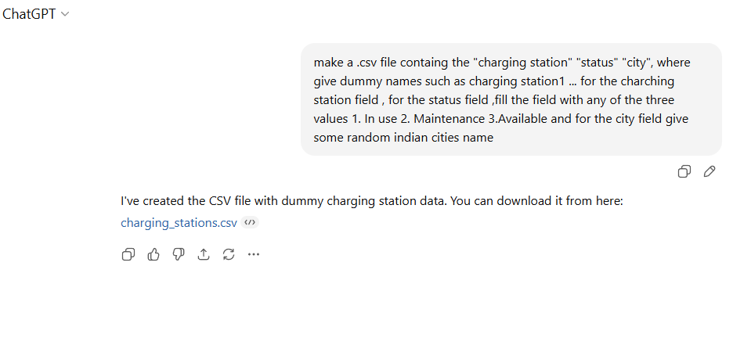

Made with the help of chat gpt

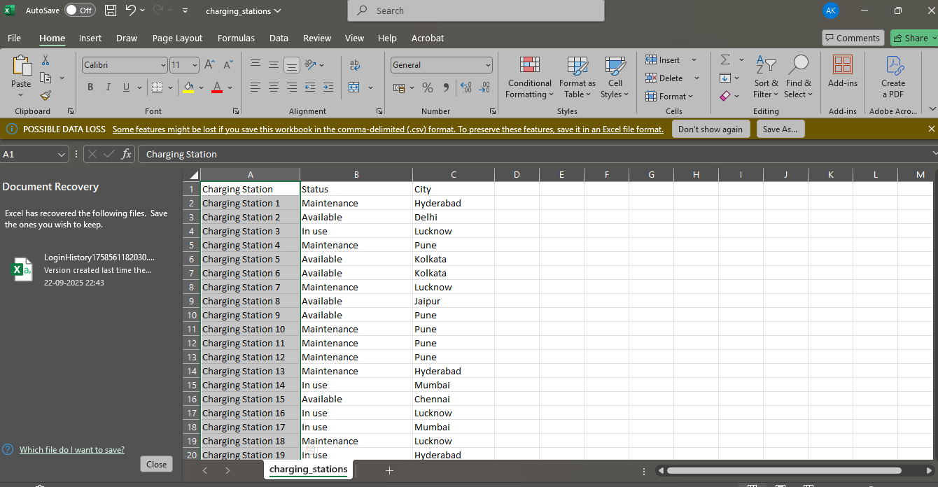

This is the csv file

2.choosing the csv file for the custom objects

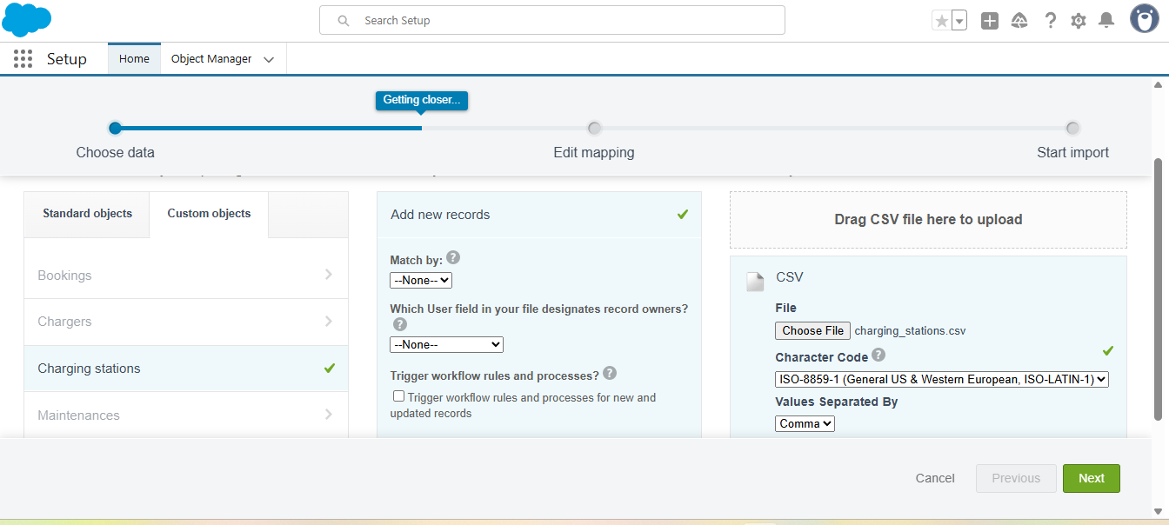

Mapping all the fields

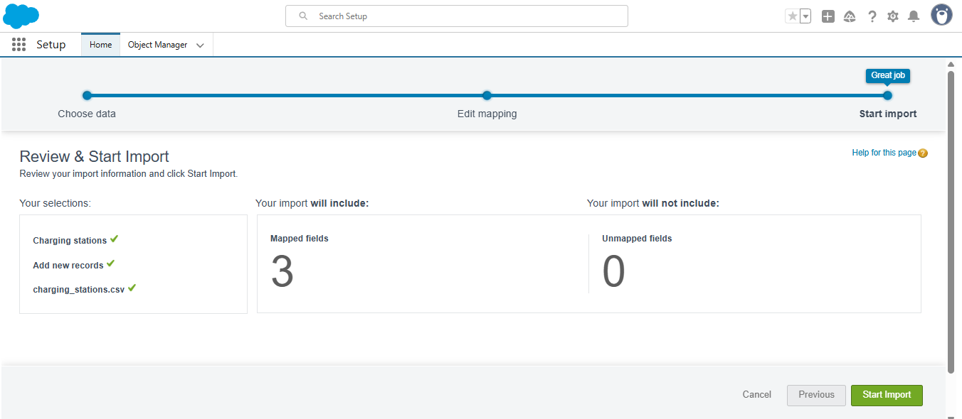

Importing has started

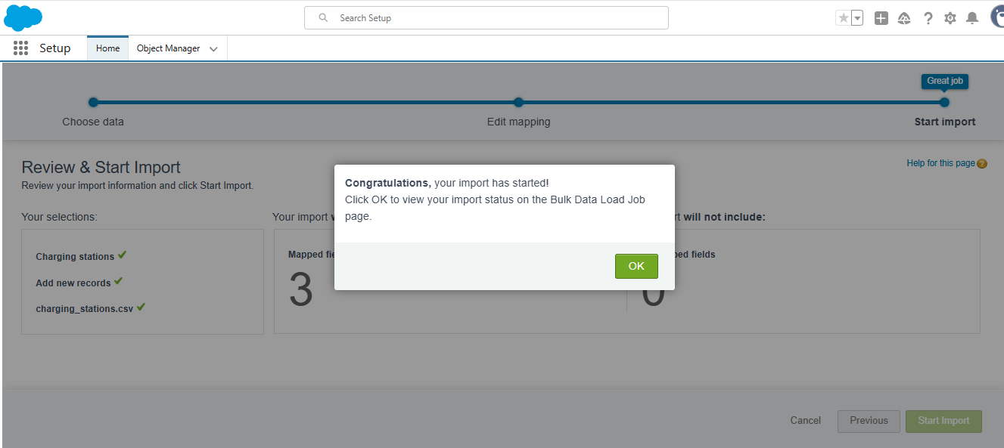

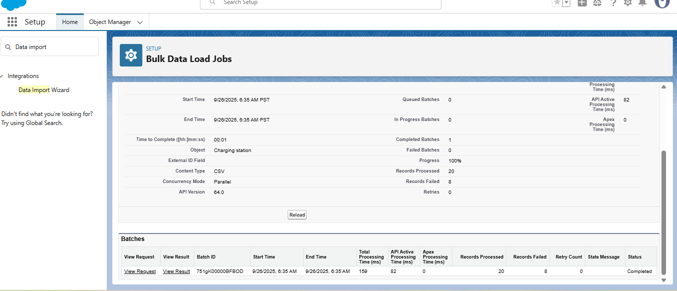

Finally the data is imported

As you can see the records have been imported

